Python-Based Machine Learning Model Development and Evaluation Plan
Project: Customer Churn Prediction
Prepared by: Krishnapriya K V
Internship: Virtual Data Science Explorer Intern
Task: Week 3 – Machine Learning Model Development and Evaluation Plan

1. Introduction
Machine Learning is an important part of a data science project because it allows computers to learn patterns from data and make predictions. In this project, the selected problem is Customer Churn Prediction.
Customer churn occurs when a customer stops using a service or cancels a subscription. A company can use customer information to identify patterns that may indicate whether a customer is likely to leave.
The objective of this Week 3 task is to prepare a detailed plan for developing a machine learning model using Python. The plan covers data preprocessing, feature selection, model selection, training, evaluation, validation, hyperparameter tuning and possible deployment.
Since no actual dataset was provided for this internship task, the examples in this report are hypothetical. No actual model training or real prediction results are claimed.

2. Problem Definition
The proposed machine learning problem is to predict whether a customer is likely to churn.
The target variable will be:
Churn
- Yes – customer is likely to leave
- No – customer is likely to stay
This is a binary classification problem because there are two possible output classes.

Example
Customer | Tenure | Monthly Charge | Support Calls | Plan | Churn
C001 | 12 | 599 | 1 | Basic | No
C002 | 4 | 899 | 5 | Premium | Yes
C003 | 24 | 699 | 0 | Standard | No
C004 | 7 | 999 | 3 | Premium | Yes
These values are only examples and do not represent a real dataset.

3. Why Customer Churn Prediction?
Customer churn prediction is a useful machine learning problem because losing customers can affect a company's revenue and growth.
If a model can identify customers who may leave, the company could take actions such as:
- Providing special offers
- Improving customer support
- Contacting dissatisfied customers
- Offering better plans
- Understanding common reasons for cancellation
This makes churn prediction a suitable example for understanding the complete machine learning workflow.

4. Objectives
The main objectives of the machine learning plan are:
- Understand the customer dataset.
- Identify the target variable and input features.
- Clean and preprocess the data.
- Handle missing and incorrect values.
- Convert categorical data into a suitable format.
- Select useful features.
- Divide the data into training and testing sets.
- Develop different classification models.
- Compare model performance.
- Use suitable evaluation metrics.
- Apply cross-validation.
- Tune important model parameters.
- Select a suitable final model.
- Plan how the model could be deployed in the future.

5. Understanding the Dataset
The proposed dataset may contain information such as:
Feature | Type | Example
Customer ID | Identifier | C001
Tenure | Numerical | 12 months
Monthly Charge | Numerical | ₹599
Plan Type | Categorical | Basic
Contract Type | Categorical | Monthly
Support Calls | Numerical | 3
Payment Method | Categorical | Online
Churn | Binary Target | Yes/No
The Churn column will be the target variable.
The remaining useful columns will be considered input features.
Customer ID would normally not be used as a prediction feature because it is only an identifier.

6. Data Preprocessing
Data preprocessing is an important step because machine learning models generally require clean and properly formatted data.
The following preprocessing steps are planned.
6.1 Handling Missing Values
Missing values will first be identified.
For example, if 1,000 customer records are available and 20 records have missing monthly charges, the missing values need to be handled.
Possible methods include:
- Mean value for suitable numerical variables
- Median value when the data contains outliers
- Mode for categorical variables
- Removing records only when appropriate
The selected method will depend on the amount and type of missing data.

6.2 Removing Duplicate Records
Duplicate records can affect model training.
For example, if the same customer record appears twice, it could give that customer more influence during training.
Duplicate records will therefore be identified and removed where appropriate.
A planned Python command is:
df.drop_duplicates()

6.3 Checking Incorrect Values
The dataset will be checked for impossible or incorrect values.
Examples:
- Tenure = -5 months
- Monthly Charge = -₹500
- Support Calls = -2
Such values should be corrected or removed after checking their source.

7. Handling Categorical Data
Machine learning algorithms generally require numerical input.
Categorical features such as:
- Basic
- Standard
- Premium
need to be converted into numerical representation.
One planned approach is One-Hot Encoding.
For example:
Plan | Basic | Standard | Premium
Basic | 1 | 0 | 0
Standard | 0 | 1 | 0
Premium | 0 | 0 | 1
Python's Pandas or Scikit-learn tools can be used for this process.

8. Feature Scaling and Normalization
Some machine learning algorithms perform better when numerical features are on similar scales.
For example:
- Tenure may range from 1–60 months.
- Monthly charge may range from ₹300–₹5,000.
- Support calls may range from 0–20.
Scaling can help prevent features with larger numerical values from dominating the model.
A method such as StandardScaler can be considered for models where scaling is useful.
Tree-based models such as Decision Tree and Random Forest generally do not require feature scaling in the same way.

9. Feature Engineering
Feature engineering means creating or modifying features to make the data more useful for the model.
Possible examples for this project include:
Customer Service Usage
A new feature could combine different support-related information.
Average Monthly Spending
If total spending and customer tenure are available:
Average Monthly Spending = Total Spending / Tenure
Customer Tenure Group
Tenure could also be grouped into categories such as:
- New customer
- Medium-term customer
- Long-term customer
Feature engineering will only be applied if it provides useful information and does not introduce data leakage.

10. Feature Selection
Not every column is necessarily useful for prediction.
Features will be examined based on:
- Relationship with the target
- Correlation where appropriate
- Domain relevance
- Missing values
- Duplicate information
- Possible data leakage
For example, Customer ID would normally be excluded because it does not provide meaningful information about churn.
Useful features may include:
- Tenure
- Monthly Charge
- Contract Type
- Plan Type
- Support Calls
- Payment Method
- Usage Information

11. Train-Test Split
After preprocessing, the dataset will be divided into training and testing data.
A possible split is:
- 80% Training data
- 20% Testing data
For example, with 1,000 records:
- 800 records → training
- 200 records → testing
The training data is used to develop the model, while the test data is kept separate to evaluate how the model performs on unseen data.
A planned Python example is:
from sklearn.model_selection import train_test_split

X_train, X_test, y_train, y_test = train_test_split(
X, y, test_size=0.2, random_state=42
)
For classification problems, stratification may also be considered to maintain a similar class distribution between training and testing data.

12. Model Selection
Different machine learning algorithms can be tested for the churn prediction problem.
The main proposed models are:
- Logistic Regression
- Decision Tree
- Random Forest
These models are suitable for a binary classification problem.

13. Logistic Regression
Logistic Regression is a simple classification algorithm that can be used to predict the probability of a customer belonging to a class.
For this project, the classes are:
- Churn = Yes
- Churn = No
Advantages
- Simple to understand
- Fast to train
- Useful as a baseline model
- Provides interpretable results
It will be used as one of the initial models for comparison.

14. Decision Tree
A Decision Tree makes predictions by creating a series of decision rules.
For example:
Is customer tenure < 6 months?
|
Yes
|
Are support calls > 3?
|
Yes
|
Higher churn risk
The actual decision rules would be learned from the training data.
Advantages
- Easy to understand
- Can handle numerical and categorical information after suitable preprocessing
- Can capture non-linear relationships
- Easy to visualize
A limitation is that a very deep tree may overfit the training data.

15. Random Forest
Random Forest is an ensemble learning method that combines multiple decision trees.
Instead of depending on one tree, several trees are created and their predictions are combined.
Advantages
- Usually more robust than a single decision tree
- Can capture complex relationships
- Can reduce overfitting compared with a single unrestricted tree
- Provides feature importance information
Random Forest will be considered as a strong candidate for the final model, but the final choice will depend on actual evaluation results.

16. Why These Models Are Selected
The three models provide different levels of complexity.
Model | Main Purpose
Logistic Regression | Simple baseline
Decision Tree | Easy-to-understand rules
Random Forest | More powerful ensemble model
Linear Regression is not selected as the main model because the target variable is Yes/No, making this a classification problem rather than a continuous-value regression problem.

17. Model Training Process
The planned training process is:
- Load the dataset.
- Separate features and target.
- Clean the data.
- Handle missing values.
- Encode categorical features.
- Select useful features.
- Split the dataset into training and testing sets.
- Apply scaling where required.
- Train the selected models.
- Generate predictions.
- Evaluate each model.
- Compare the results.
- Tune model parameters if required.
- Select the most suitable model.
A simple planned Python structure is:
from sklearn.linear_model import LogisticRegression

model = LogisticRegression()
model.fit(X_train, y_train)

predictions = model.predict(X_test)
This is an example of the planned implementation and is not presented as an executed result.

18. Hyperparameter Tuning
Hyperparameters are settings that are chosen before model training.
Examples include:
Decision Tree
- Maximum tree depth
- Minimum samples required for a split
Random Forest
- Number of trees
- Maximum tree depth
- Minimum samples for splitting
Logistic Regression
- Regularization strength
The project can use methods such as:
- Grid Search
- Random Search
For example, GridSearchCV can test different combinations of parameters and identify a suitable combination based on the selected evaluation metric.

19. Model Evaluation
After training, the models need to be evaluated using data that was not used for training.
For the customer churn problem, the following metrics will be considered:
- Accuracy
- Precision
- Recall
- F1-score
- Confusion Matrix
- ROC-AUC
Using multiple metrics is important because accuracy alone may not provide enough information, especially when the number of customers who churn is much smaller than the number who do not churn.

20. Accuracy
Accuracy represents the percentage of total predictions that are correct.
Formula:
Accuracy = Correct Predictions / Total Predictions
For example, if a model correctly predicts 180 out of 200 customers:
Accuracy = 180 / 200 = 90%
However, accuracy should not be used alone if the dataset is imbalanced.

21. Precision
Precision answers:
“Of the customers predicted as churners, how many actually churned?”
High precision means the model produces fewer false positive predictions.
Precision can be useful when unnecessary retention actions could be costly.

22. Recall
Recall answers:
“Of all customers who actually churned, how many did the model identify?”
For a churn prediction system, recall can be particularly important because missing a customer who is actually going to leave may result in lost business.

23. F1-Score
F1-score combines precision and recall into a single measure.
It is useful when both false positives and false negatives are important.
The F1-score is calculated using:
F1 = 2 × (Precision × Recall) / (Precision + Recall)
A higher F1-score generally indicates a better balance between precision and recall.

24. Confusion Matrix
A confusion matrix shows how many predictions fall into each category.
 | Predicted No | Predicted Yes
Actual No | True Negative | False Positive
Actual Yes | False Negative | True Positive
For churn prediction:
- True Positive: Customer predicted to churn and actually churned.
- True Negative: Customer predicted not to churn and actually stayed.
- False Positive: Customer predicted to churn but actually stayed.
- False Negative: Customer predicted not to churn but actually churned.
This helps understand the types of mistakes made by the model.

25. ROC-AUC
ROC-AUC can be used to evaluate how well a classification model separates the two classes.
The ROC curve compares the true positive rate with the false positive rate at different classification thresholds.
The AUC value represents the overall ability of the model to distinguish between churn and non-churn customers.
A higher AUC generally indicates better class separation.

26. Cross-Validation
Cross-validation is used to check whether the model performs consistently on different portions of the training data.
A possible approach is 5-fold cross-validation.
The training data would be divided into five parts.
Fold 1 | Fold 2 | Fold 3 | Fold 4 | Fold 5
The model is trained using four parts and validated using the remaining part. This process is repeated five times so that each part is used for validation.
The results can then be averaged.
This gives a more reliable estimate of model performance than using only one validation split.

27. Avoiding Overfitting
Overfitting occurs when a model learns the training data too closely and performs poorly on new data.
Possible ways to reduce overfitting include:
- Limiting Decision Tree depth
- Using Random Forest
- Cross-validation
- Feature selection
- Regularization
- Hyperparameter tuning
- Keeping a separate test dataset
The training and testing data should not be mixed during the process.

28. Data Leakage
Data leakage occurs when information that should not be available during prediction is accidentally used by the model.
For example, if a feature contains information that becomes available only after the customer has already cancelled their service, using that feature would give the model unrealistic information.
Therefore, all features will be checked carefully before training.

29. Proposed Python Workflow
The complete planned workflow is:
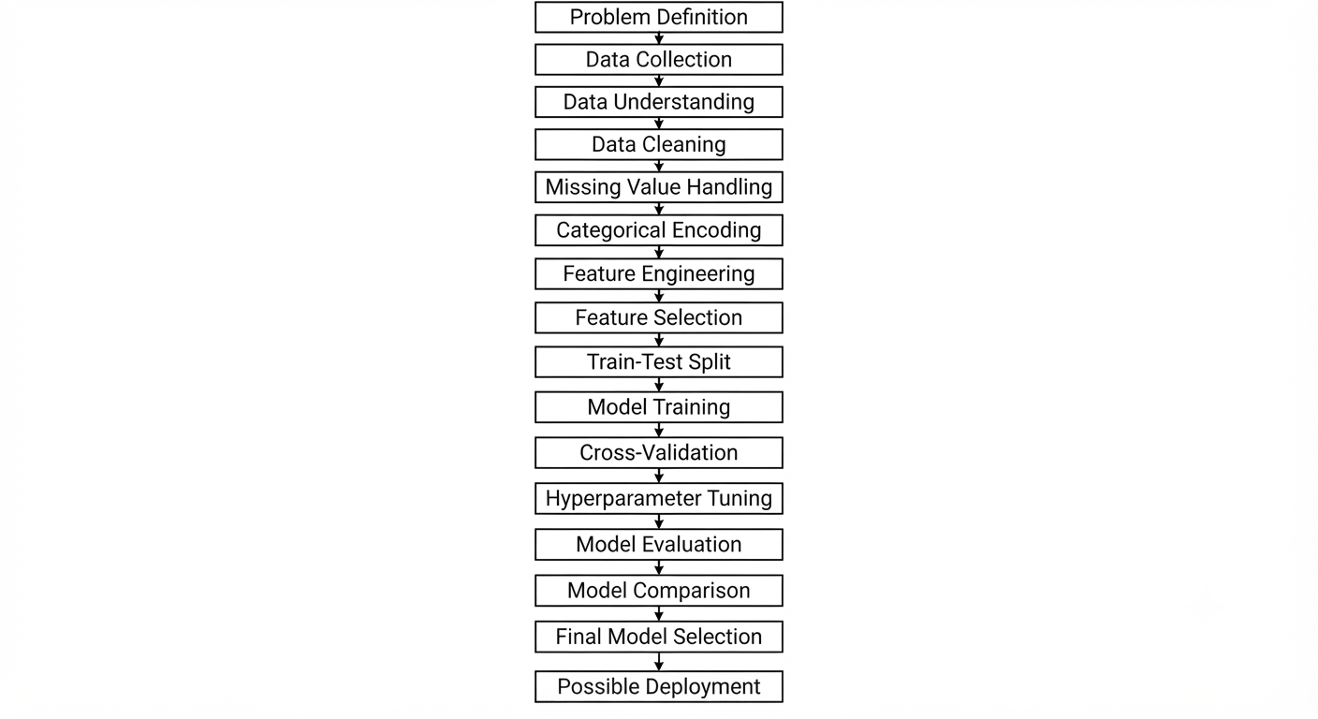

30. Tools and Python Libraries
The following tools and libraries are planned for the project.
Python
Python will be the main programming language.
Pandas
Used for loading, cleaning and manipulating tabular data.
NumPy
Used for numerical operations.
Matplotlib
Used for creating basic charts and graphs.
Seaborn
Used for statistical visualizations.
Scikit-learn
Used for machine learning models, preprocessing, train-test splitting and evaluation.
Jupyter Notebook
Can be used to write and execute Python code step by step.

31. Possible Challenges and Solutions
Challenge | Possible Solution
Missing values | Use suitable imputation methods
Duplicate records | Identify and remove duplicates
Incorrect values | Validate and correct data
Categorical variables | Apply encoding
Different feature scales | Use scaling where required
Outliers | Investigate before removing
Imbalanced classes | Use suitable metrics and validation methods
Overfitting | Use cross-validation and tuning
Data leakage | Check features before training
Too many features | Apply feature selection

32. Model Comparison Plan
After training the models, their performance will be compared using a table.
An example format is:
Model | Accuracy | Precision | Recall | F1 | ROC-AUC
Logistic Regression | To be calculated | To be calculated | To be calculated | To be calculated | To be calculated
Decision Tree | To be calculated | To be calculated | To be calculated | To be calculated | To be calculated
Random Forest | To be calculated | To be calculated | To be calculated | To be calculated | To be calculated
Important: Actual values will only be entered after training the models on a real dataset. No values are invented in this planning report.
The final model will be selected based on the evaluation results and the practical requirements of the churn prediction problem.

33. Possible Model Deployment
After a suitable model has been selected and properly tested, it could eventually be deployed as a simple application or service.
A possible deployment process is:
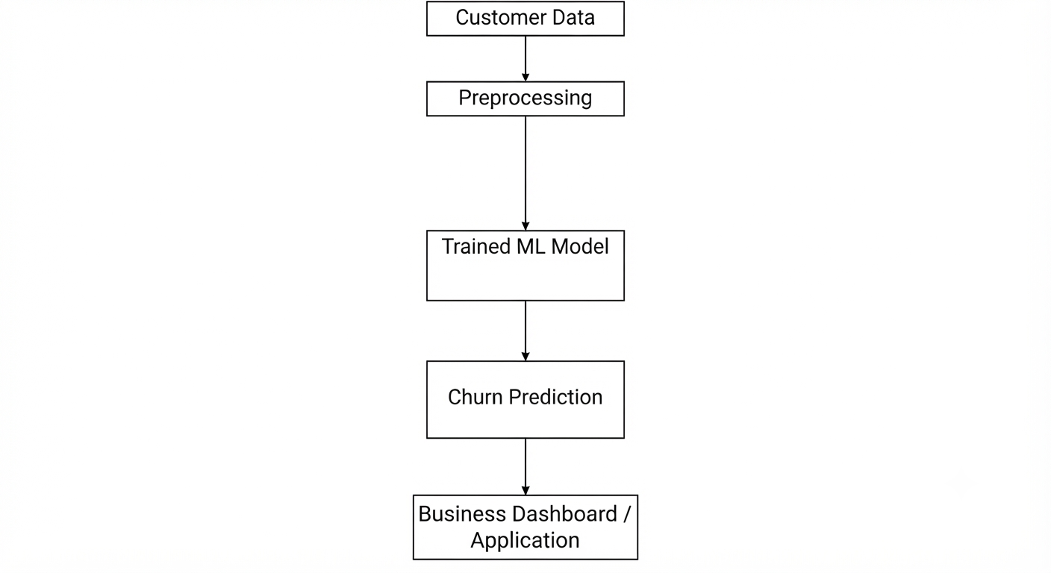
For example, a company could enter customer information into an application and receive a prediction such as:
Low churn risk or High churn risk
The model would need to be monitored after deployment because customer behaviour can change over time.

34. Model Maintenance
A deployed model should not be considered permanently finished.
Customer behaviour, pricing, services and market conditions can change. Therefore, the model should be monitored regularly.
Possible maintenance activities include:
- Checking model performance
- Monitoring new customer data
- Checking changes in data patterns
- Retraining the model when necessary
- Updating features
- Checking for prediction errors
- Monitoring data quality
This helps maintain the usefulness of the model over time.

35. Expected Outcomes
The expected outcome of this planned machine learning project is a structured process for developing a customer churn prediction model.
The project is expected to:
- Demonstrate the complete machine learning workflow.
- Prepare customer data for modelling.
- Compare different classification algorithms.
- Use suitable evaluation metrics.
- Understand model validation.
- Identify a suitable model after actual testing.
- Provide a possible path toward deployment.
Since this Week 3 task is a planning exercise, these are expected outcomes rather than actual model results.
36. Project Timeline
A total of approximately 32 hours can be planned for the complete machine learning development and evaluation process.
Activity | Estimated Time
Problem definition and dataset understanding | 3 hours
Data preprocessing plan | 5 hours
Feature engineering and selection | 4 hours
Model selection | 3 hours
Training process planning | 4 hours
Evaluation metrics | 3 hours
Cross-validation and tuning | 4 hours
Deployment and maintenance planning | 2 hours
Documentation and review | 4 hours
Total | 32 hours

37. Conclusion
This Week 3 report presents a structured plan for developing and evaluating a machine learning model for customer churn prediction using Python. The plan covers the main stages of a machine learning project, starting from problem definition and data preprocessing and continuing through feature selection, model training, evaluation and possible deployment.
Logistic Regression, Decision Tree and Random Forest are proposed as the main classification models. Different evaluation metrics such as accuracy, precision, recall, F1-score, confusion matrix and ROC-AUC will be considered to compare their performance.
Cross-validation and hyperparameter tuning will also be used as part of the planned process to improve the reliability of the model. Issues such as overfitting, data leakage, missing values and imbalanced data will be considered during development.
Since no actual dataset was provided for this assignment, the examples and workflow described in this report are hypothetical. Actual model performance and results would only be calculated after implementing the plan with a suitable dataset.

